# Exercise 3: Terrain and Precipitation Data Analysis

## Objectives

* Select, download, import, and display SRTM terrain data in QGIS
* Use QGIS to create a derived slope product and flow direction from terrain data
* Analyze precipitation, terrain, and slope data to identify low-lying areas where waterlogging may occur

## Outline

1. Access SRTM Elevation Data Products
2. Import and Visualize the SRTM Elevation Data in QGIS
3. Derive Slope from the SRTM Digital Elevation Model
4. Import Half-Hourly IMERG Precipitation
5. Creating a Flow Direction Product from the DEM

## Part 1: Access SRTM Elevation Data Products

* Go to the GDEx portal: <http://gdex.cr.usgs.gov/gdex/>
* From the top menu bar, click **Log in**
* Login with your NASA Earthdata username and password
* Click on the **xy** in the menu bar, and you will get a window to enter the desired latitude and longitude to select a rectangular region. Enter:
  + Latitudes: 37.0N and 40.5N
  + Longitudes: -124.5W and -119.5W
  + *Note: This covers California, where GPM IMERG showed large rainfall in Exercise 1, from January 8-11.*
* Click **Submit**

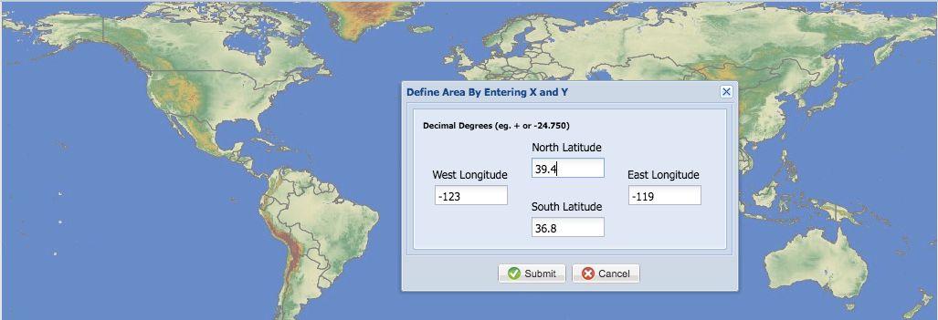

* Macintosh HD:Users:amitamehta:Desktop:Screen Shot 2017-04-01 at 2.58.53 PM.pngYou will see a box over California
* Click on the **Download** button in the menu bar
* A window will pop up

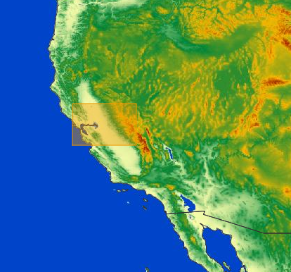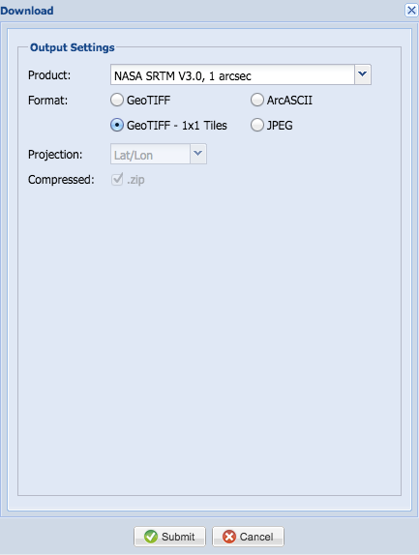

* Next to Product, select **NASA SRTM V3.0, 1 arcsec** from the drop-down list
* Select **GeoTIFF – 1x1 Tiles**
* You will get a message window that says, **Please Wait: Your request is being processed**
  + *Note: The number of tiles cannot exceed 36. If the domain is too large, then the data has to be downloaded in multiple steps*
* Once the data files are ready to be downloaded, you will get a window where you can select **Download** (at the bottom of the window). Save the data files on your computer. You will be able to name the data when you save the files.
* You will see the data in a .zip file after you save them on your computer.
* Double click to unzip the data.
* You will get a folder with SRTM terrain tiles for California in TIFF format.

**Question**

1. How many TIFF images do you see in the folder?

## Part 2: Import and Visualize SRTM Elevation Data in QGIS

* Open **QGIS** on your desktop
* First add in a base map from **Web** using the **OpenLayers Plugin**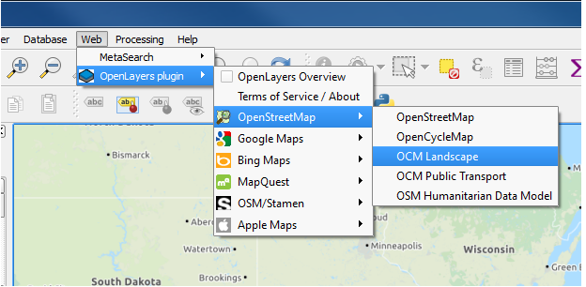
* Choose the base map of your choice (here we will use **OpenStreetMap**)
* Zoom in on the study area: California
* 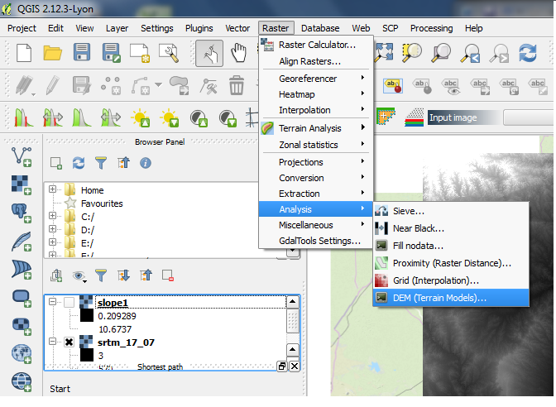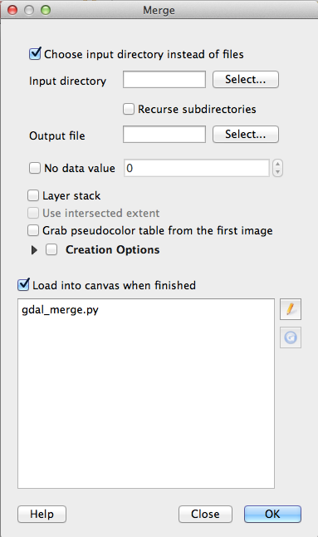Go to the QGIS top bar and click on **Raster**
* From the drop-down menu, go to **Miscellaneous** and select **Merge**
* A window will open for you to navigate to the location of the downloaded SRTM product
* Select **Choose input directory instead of files** since there are multiple SRTM tiles in the .tiff files (you can also choose to merge one tile at a time)
* Click **Select** next to **Input Directory**
* You will see a list of all the files in the directory under **Load into canvas when finished**
* Click **Select** next to **Output File.** This will open a new window where you can **Select where to save the merge output.**
* 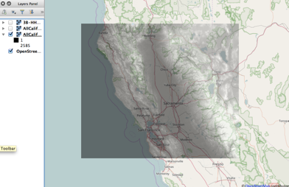Enter the name you want to save the merged SRTM tiles under and click **Save**
* Click **OK** at the bottom of the **Merge** window
* It may take a few seconds to a few minutes for the files to save – it depends upon the number of tiles being merged
* Once the tiles have been merged, the new raster with the output file name you assigned will be imported on the QGIS window
* Once the raster has been imported, you may wish to change the transparency of the DEM file in order to view the base map with elevation properties
* The black areas show low terrain, and the white areas show high terrain

## Part 3: Derive Slope from the SRTM DEM

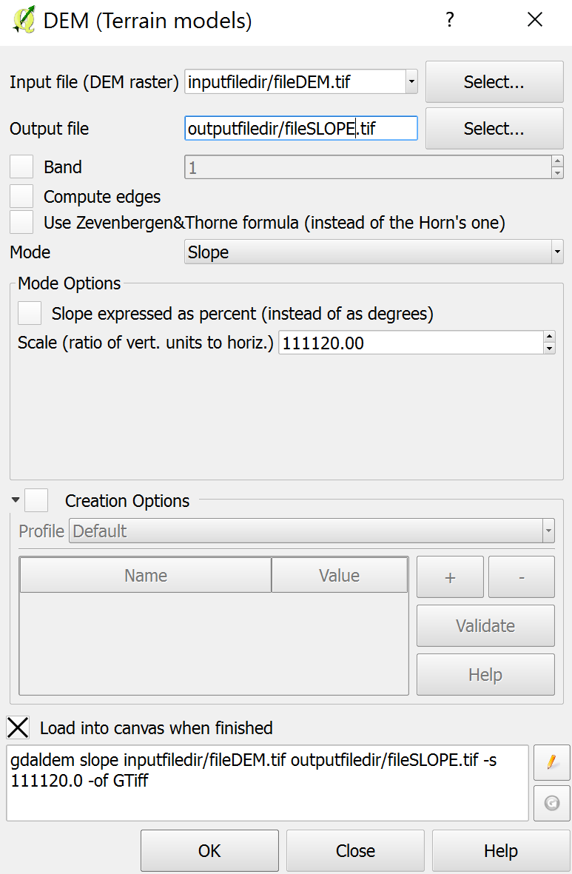

* Using the SRTM DEM now imported into QGIS we can create a slope product using the **DEM (Terrain Models) Tool**
* Click on the Menu Item: **Raster** > **Analysis** > **DEM (Terrain Models)**
* In the dialog that appears, ensure the **Input file** is the merged DEM we just visualized
* Set the **Output file** to a folder and name ending in .tiff
* Set the **Mode** option to **Slope**
* Check the **Slope expressed as percent** box
* In the **Scale** box, enter 111120.00 to convert the units to meters
* Click **OK**
* The resulting image displays the slope as percentage
* You can change the color of the slope to see the details by double clicking or right clicking on the **Slope** layer, and selecting **Properties.** 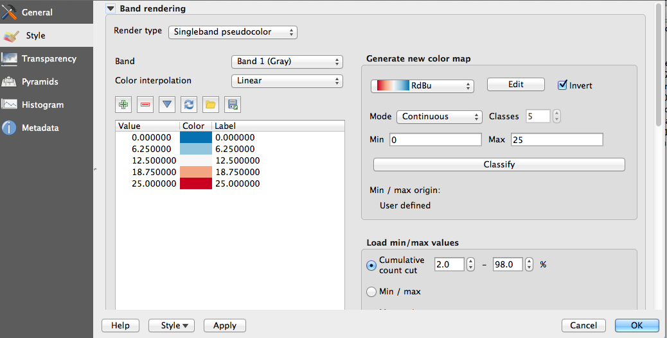
* From the left side menu select **Style**
* Under **Render Type** select **Singleband pseudocolor**
* Choose a color table from **Generate new color map**
* Set **Mode** as **Equal Interval**
* In classes, enter **5** intervals
* Click on **Apply** and **OK**
* From the left side menu select **Transparency** and choose the appropriate percent value of transparency to see the OpenStreet Map under the precipitation layer
* You will get the slope map as shown below
* The high slopes are red, and the low slopes are blue
  + *Note: In this example the colors are inverted*
* Generally, low slope terrain surrounded by higher slope terrain has an increased potential for flooding and waterlogging

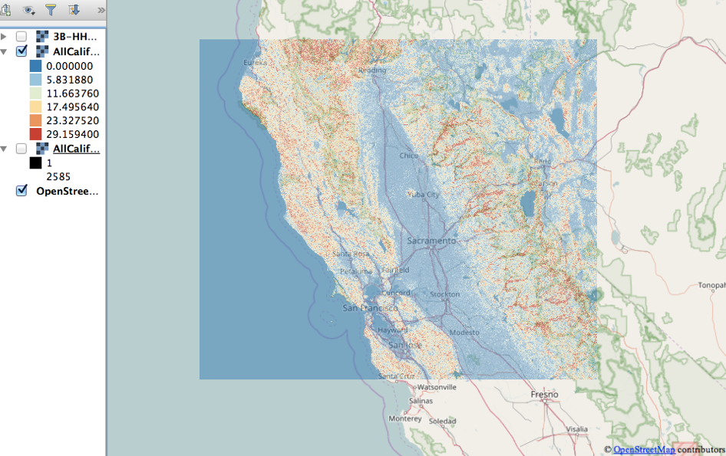**Questions**

1. What is the slope range around Sacramento? (Zoom in on the map)
2. Compare the slope structure around Berkeley to that of Sacramento. Just based on the slope, which city has higher potential of getting more rain water accumulation?

## Part 4: Import Half-Hourly IMERG Precipitation

* Click on the **Add Raster Layer** button and pick the half-hourly IMERG precipitation rate you saved in GeoTIFF format using the python script
* Follow the same steps as for the DEM Slope layer in Part 3 to change color and transparency of the precipitation layer
* In the QGIS window, you will see the SRTM DEM, slope, and half-hourly IMERG precipitation rate, in addition to the OpenStreetMap
* You can turn layers on and off, and change colors or transparency to analyze the information

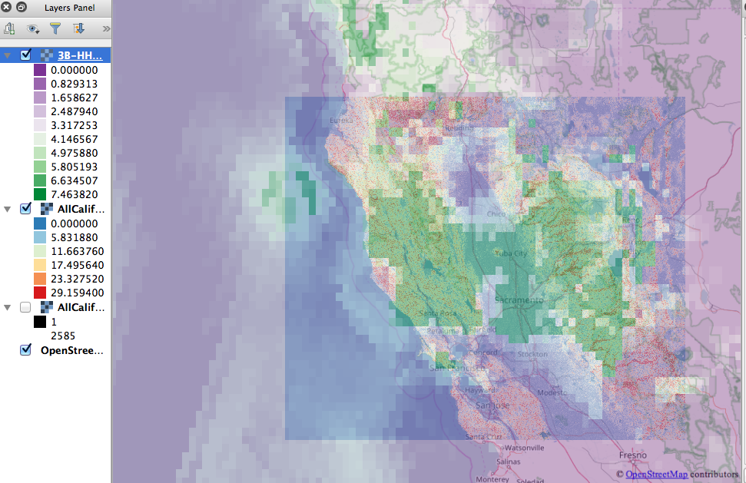**Questions**

1. What are the units of the half-hourly precipitation rate? (Hint: this information is available from Giovanni or PPS)
2. What is the maximum precipitation rate observed for this region? (Min and max values are in the layer information)
3. What are three cities where the rain rate is greater than 4 mm/hr?
4. Discussion: for the terrain, slope, and precipitation information is it possible to decide where more water may accumulate? Sacramento or Santa Rosa?

### Optional (if you have time)

## Part 5: Reprojection of DEM Data

* You may find that some raster features do not work correctly unless the data are in the appropriate units or projection.
* For DEM, and for many functions, the data needs to be projected into meters
* In the lower, right-hand corner of QGIS, there is a Coordinate Reference System option that is marked by **EPSG** followed by a number such as EPSG: 3857. Click on the globe icon to the right of the label to open **Project Properties: CRS (Coordinate Reference System)**
* In the top click **Enable on the fly CRS transformation**
  + If the CRS is not EPSG:3857 then in the Filter Box type: **3857**.
  + Click **Apply**, **OK**
* Right click on the name of the layer and select **Save As**
  + Choose the name and location of the new projected raster
* Use the saved, EPSG:3857 layer in subsequent analysis

## Part 6: Creating a Flow Direction Product from DEM

* Example shown here is for a single SRTM tile
* You can use a single SRTM DEM file (area covering Monterey near -123W and 38N)
* Type **r.fill.dir** into the **Processing Toolbox** to open the r.fill.dir tool
* 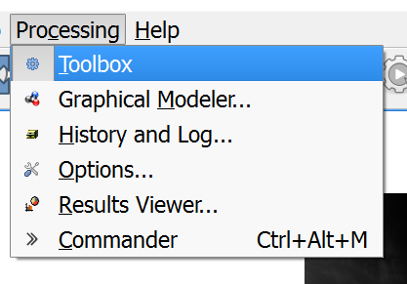The Processing Toolbox should be on the right side of the screen. If you do not see it, go to the menu and turn on the Professing Toolbox
* The r.fill.dir tool creates three outputs from the given DEM
  1. A **Depressionless DEM**, which fills sinks, small water bodies, and some errors created in DEM creation
     + Many of these sinks are not visually noticeable, and filling will not alter the appearance of the DEM, however, it is useful for hydrologic modeling
  2. A **Flow Direction** file, which gives the direction of flow, if water were dropped onto any point of the raster
  3. A **Problem Areas** file, which shows where the sinks were that are filled
* For this exercise, we will only be needing **Flow Direction**

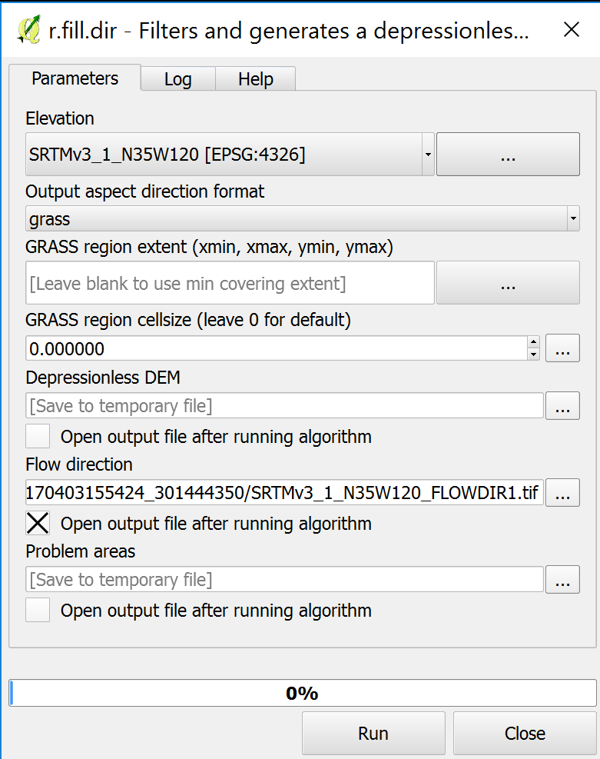

Input File

Output File

* The only input that is necessary is the DEM
* Create a filename for the Flow Direction file
* Uncheck the boxes below **Depressionless DEM** and **Problem areas** – we do not need this output
* After recording the output, we can see the shape of features in the terrain as well as knowing which direction water will flow based on surrounding features.

